# Chapter 1: Introduction

This assignment report will show you how to use the Django framework to create The N Collection Web App. Django is a Python-based free software framework for building web applications. This Django-based TheNCollection comprises four key components, each with its functionality but a familiar layout. The technologies used while making this framework were Python, JavaScript, HTML, Django, and Bootstrap. In addition, a review portion of this document gives a unique perspective on what was done with this project.

## Introduction of the project

The N Collection Is a Django web app where users can share any form of a file, including images, text files, pdf, documents, videos, and applications such as Java code, py code, etc. The technologies used for making this framework were Django, Python, JavaScript, HTML, and Bootstrap. Users can overview the website and see other users' shared files without logging in. Users can create an account using their email and password. Users need to sign up and register an account to upload their files and share them with other people. There is an admin panel for the administration user where they can delete the post of users, promote users to admin and delete the user account.

## The Features of TheNCollection Django Web App Are:

* The user's profile photo can be customized on the user's profile.
* People can download files that other users have published.
* Users can share any form of a file, including images, text files, pdf, documents, videos, and applications such as Java code, py code, etc.
* Users can preview other user profile names, phone numbers, emails, and photos.
* Admin can review user's posts and can delete user's posts if needed.
* Users can reset the password of their account if they forget it through email verification.
* There is also a password change feature to change the password of a user's account.
* Users can update their name, email, and phone number if needed.
* Admin can promote users and can delete their accounts.

## Aim

The main goal of this project is to provide users with an environment where they can share their thoughts, files, and media with other people. People can upload helpful information or any different educational pdf or documents and share them online. The main aim of this project is to connect people and their thoughts. This framework is convenient for student's community and educational purposes.

## Objectives:

The main objective is to create forums for people to discuss personal information, activities, messages, and, often most significantly, images. In addition, users can register an account with an email and share files with people. However, sharing explicit photos is prohibited. The admin can delete the user post and deactivate the user account if he finds someone sharing them.

## overview of the system:

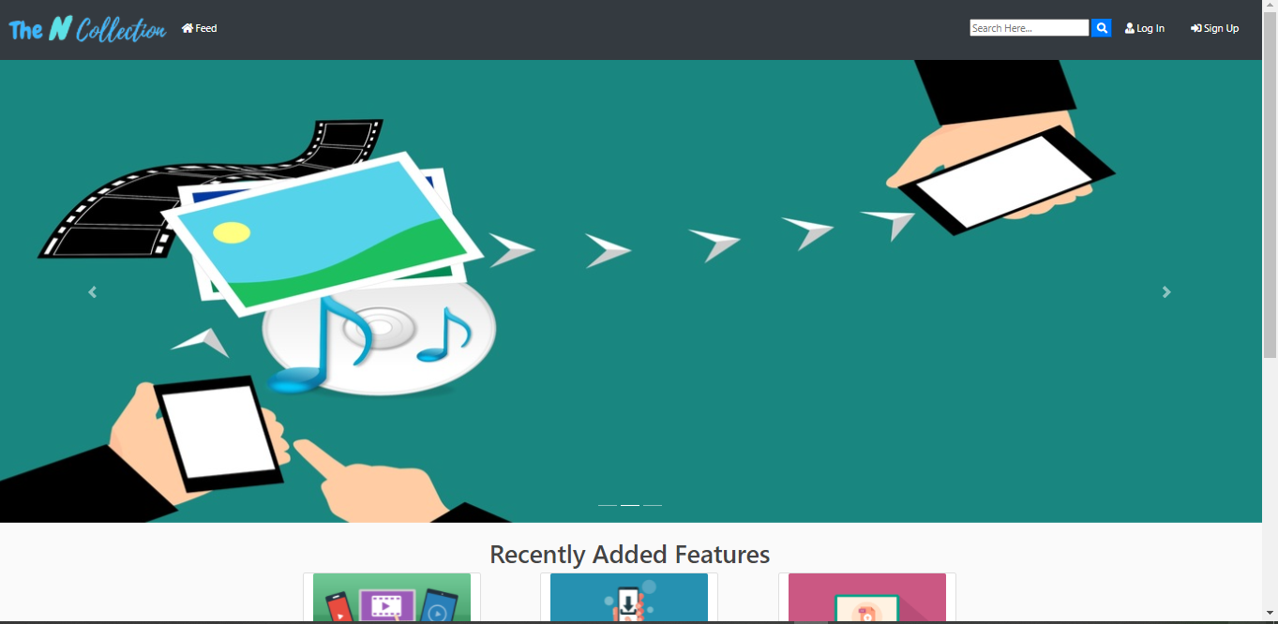

Figure 1: Homepage

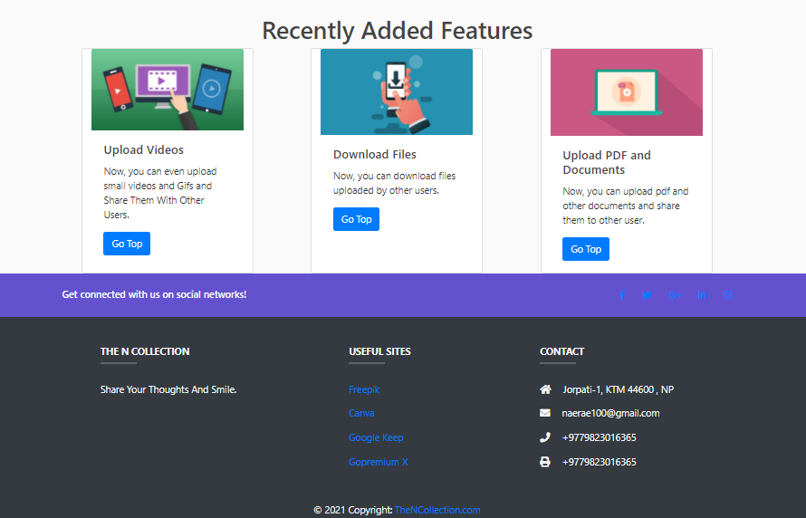

Figure 2: Footer Page

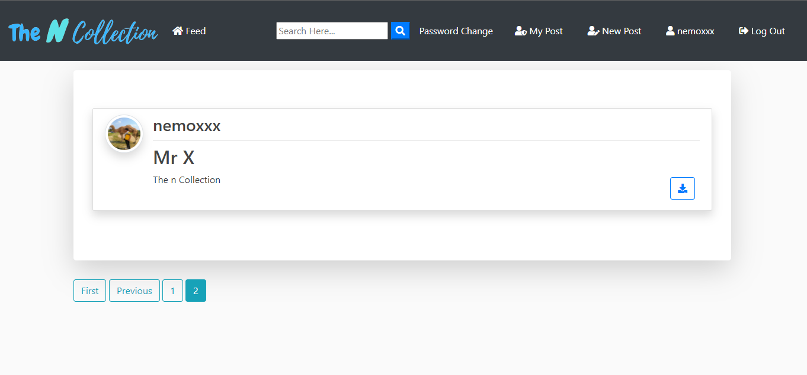

Figure 3: Feed

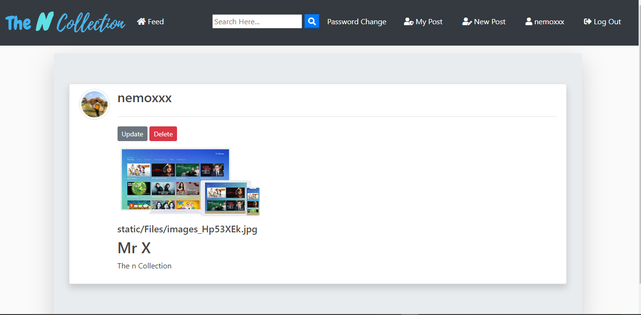

Figure 4: Shared Files

# Chapter 2: Frontend

## Tools and Technologies

The technologies used while making this framework were Jquery, CSS, JavaScript, HTML, and Bootstrap.

### HTML

The computer language used to create websites is known as HyperText Markup Language (HTML). HTML is just a collection of short characters written into a text document. Users are directed to new pages by clicking on a special text known as hyperlinks.

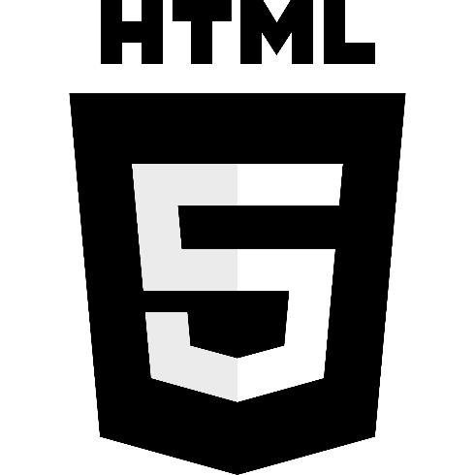

Figure 5: HTML LOGO

### CSS

CSS is a mark-up language used to describe the design and layout of the webpage. CSS is a style sheet language for the website. It can be used with any XML-based scripting language and is not dependent on HTML.

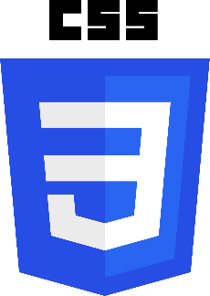

Figure 6: CSS Logo

### JavaScript

Java Script ​is a programming language that is text-based and is used on both applications and databases. It adds interactive aspects to websites to keep users interested. JavaScript can be found in places like Amazon's address bar and The New York Times' daily summary clip.

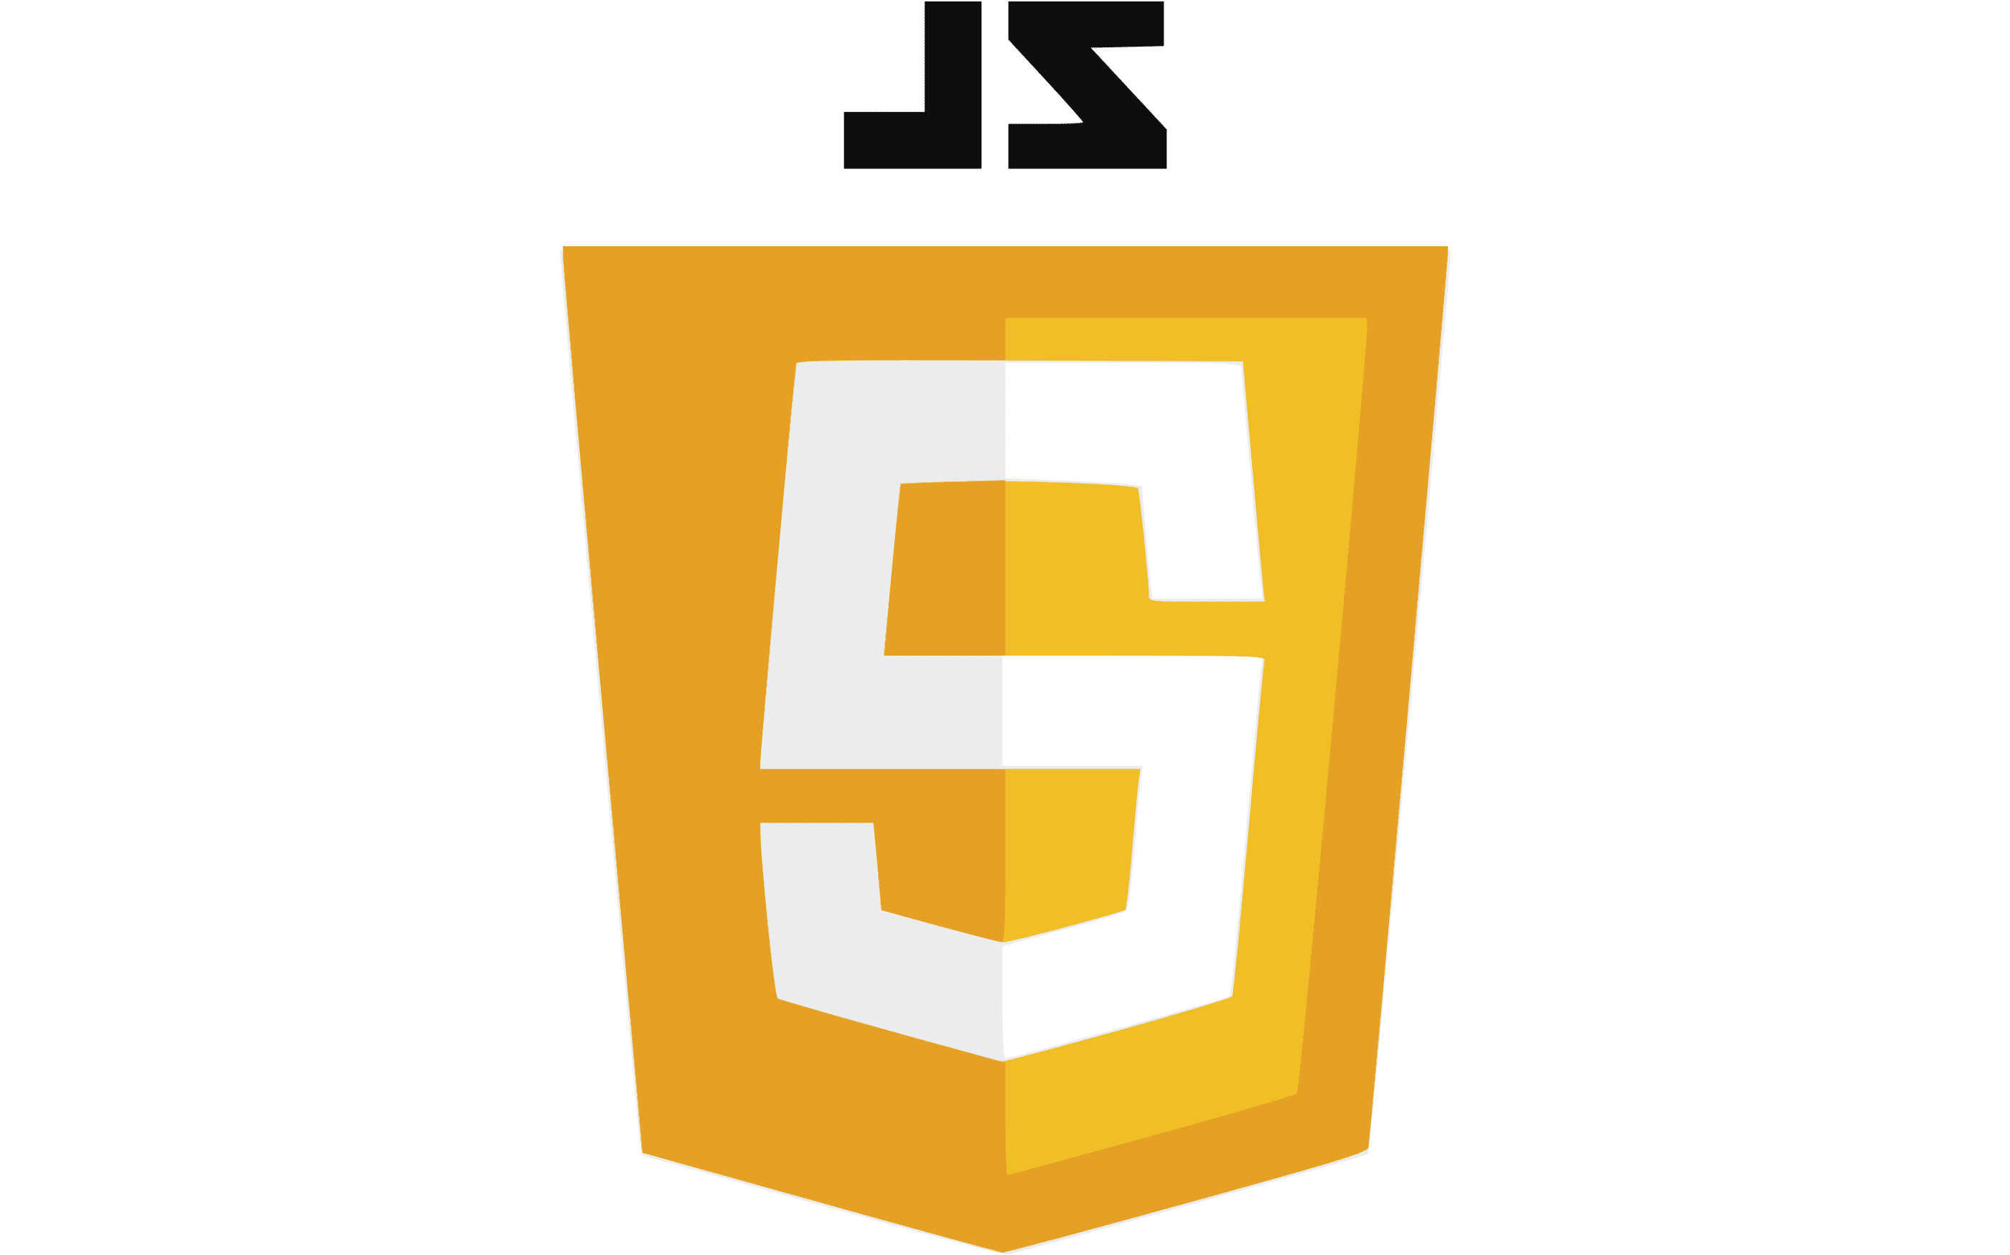

Figure 7: Java Script Logo

## Screenshot:

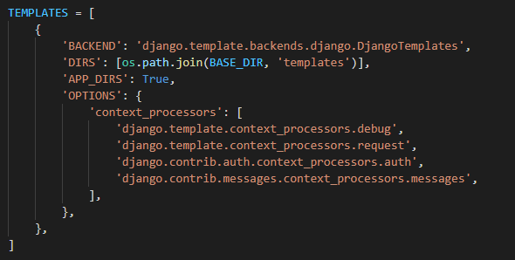

Figure 8: Template Configuration

### HTML Figures:

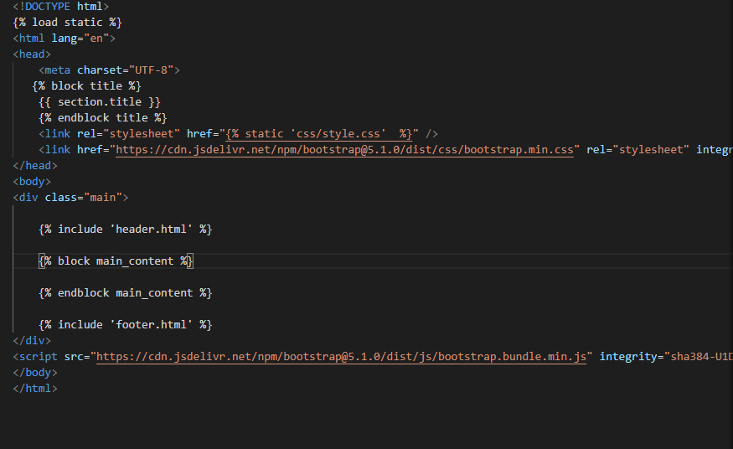

Figure 9: Layout.html

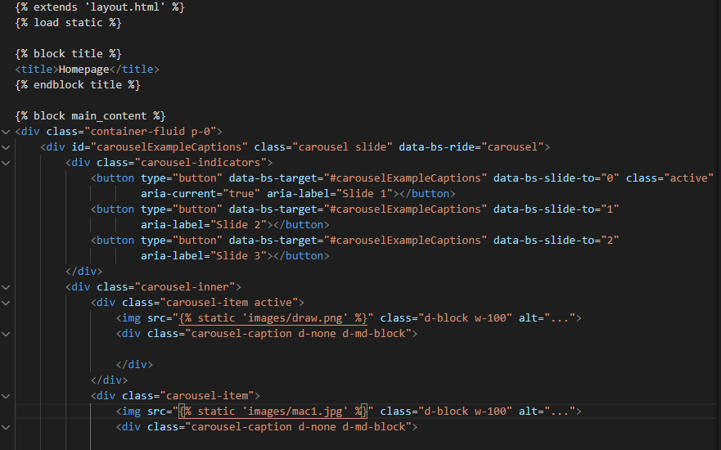

Figure 10: Homepage.html

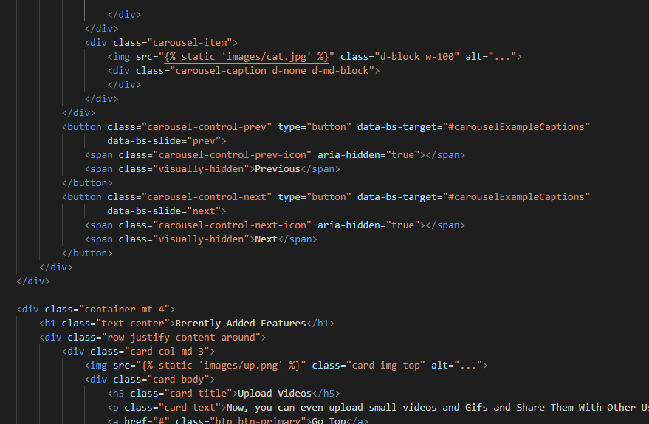

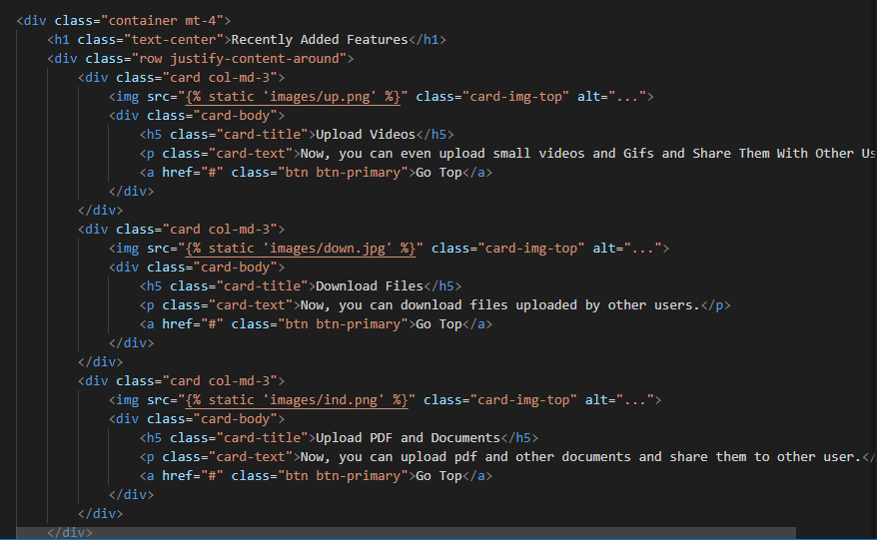

### Website view:

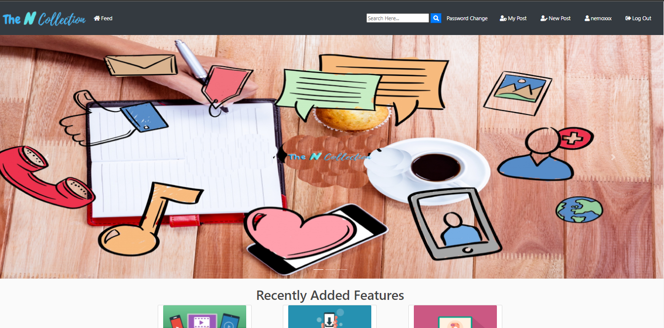

Figure 11: Homepage



Figure 12: Feed Home

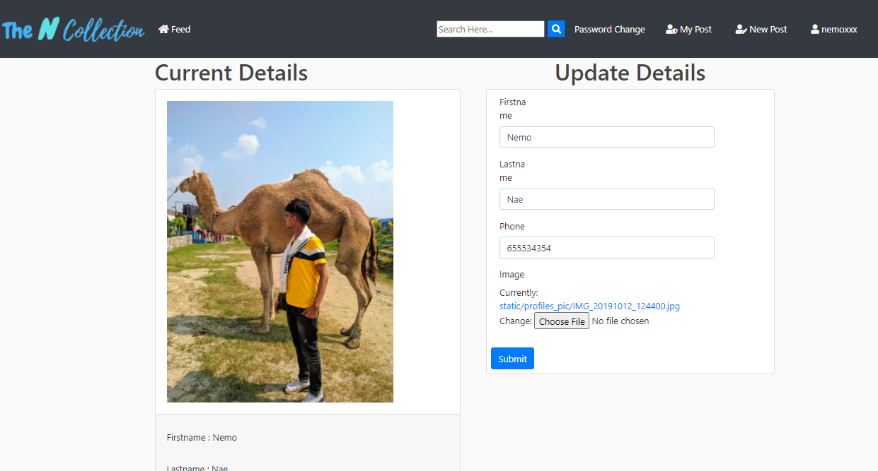

Figure 13: Profile

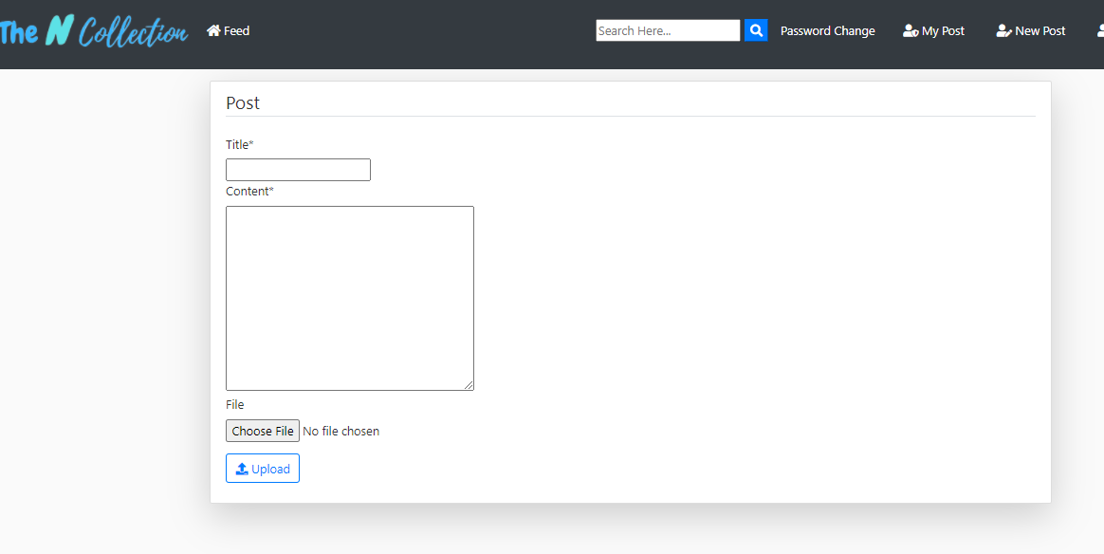

Figure 14: New Post

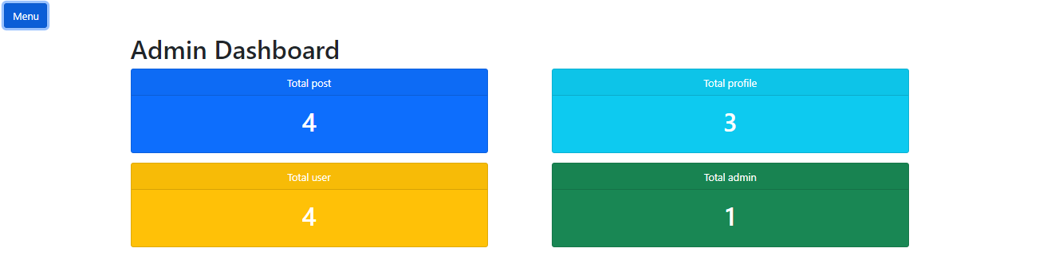

Figure 15: Admin Panel

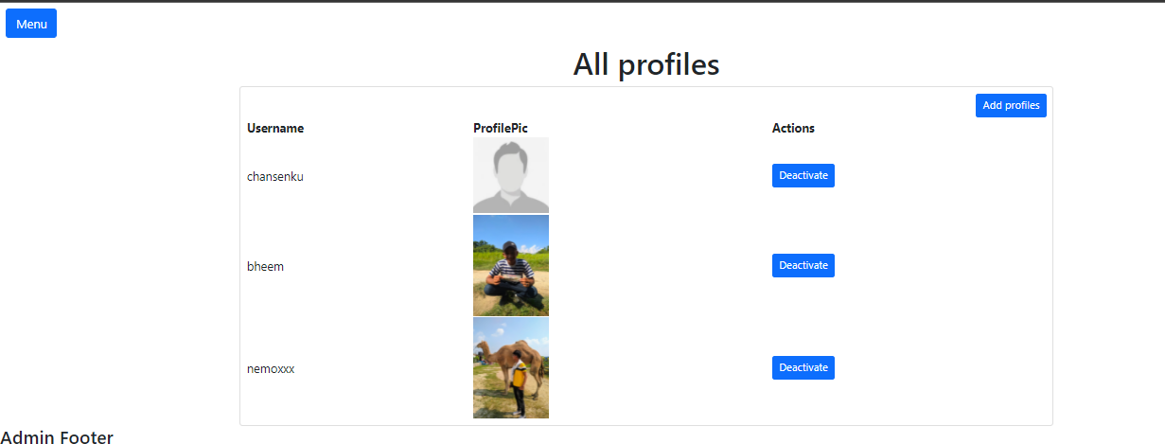

Figure 16: Admin Features

### CSS Figures:

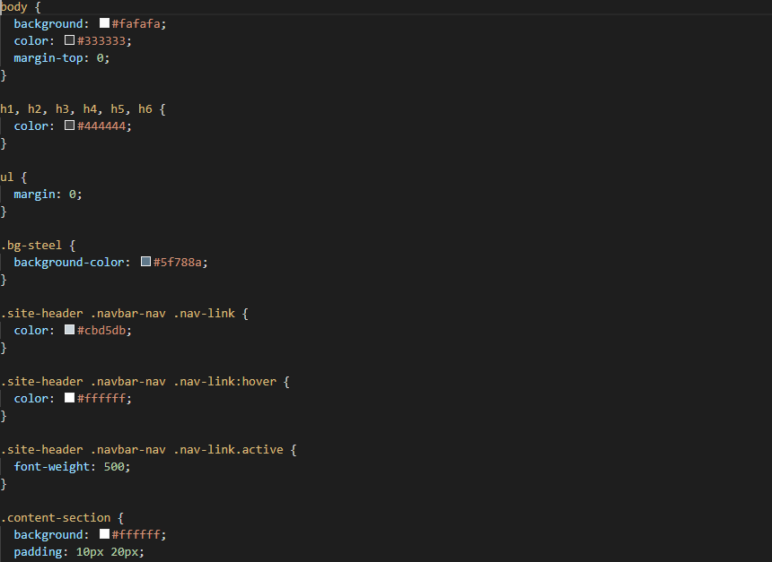

Figure 17: main.css

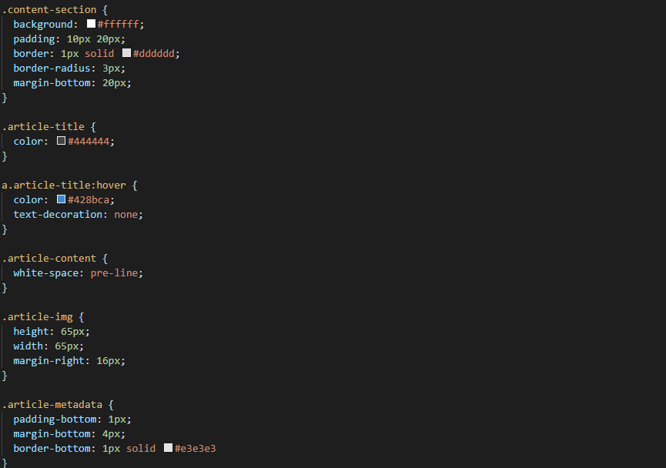

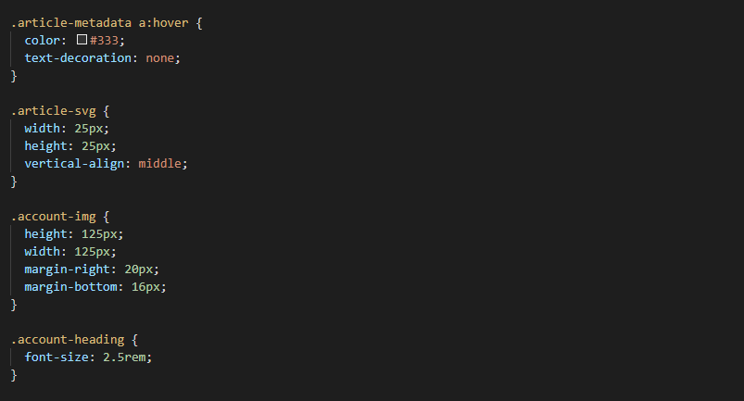

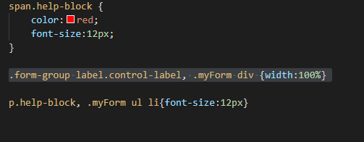

Figure 18: style.css

### Javascript Figures:

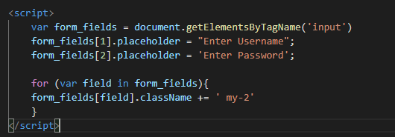

Figure 19: Java Script

### Importance of responsive design

Responsive design is a method of building a website that adapts its information and components to fit the display resolution on which it is displayed. It prohibits visuals from becoming broader than the screen width, making it easier for users to view your information on mobile platforms. The actual objective of responsive web design is to eliminate the need for excessive cropping, navigating, scaling, or rotating, which usually comes on sites that are not mobile-friendly.

### Responsive Check:

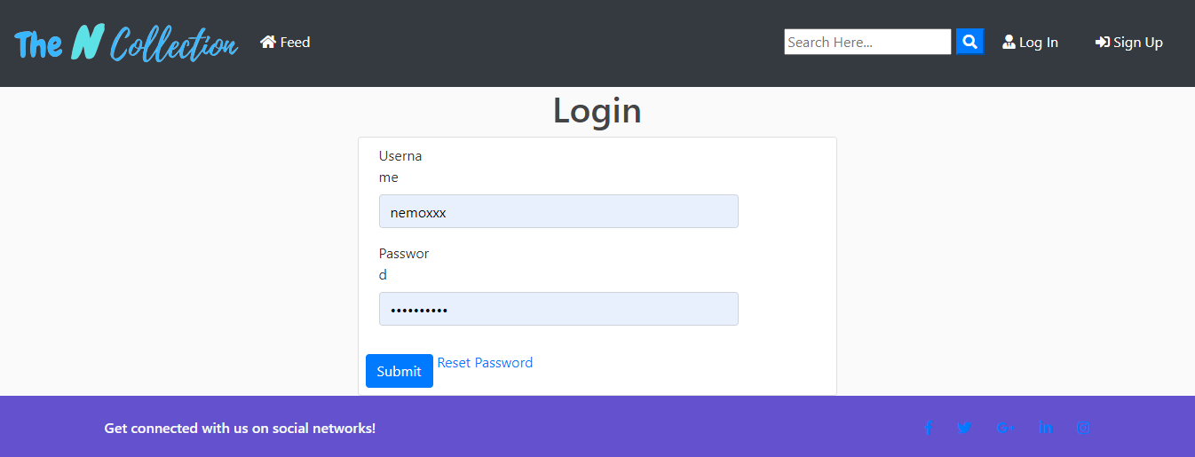

Figure 20:Login in Desktop View

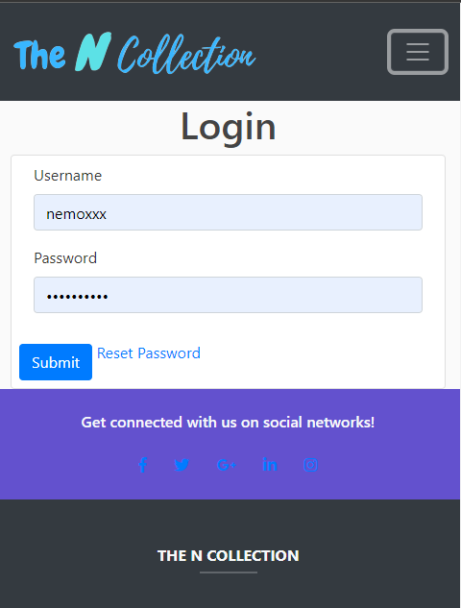

Figure 21:Login in mobile view

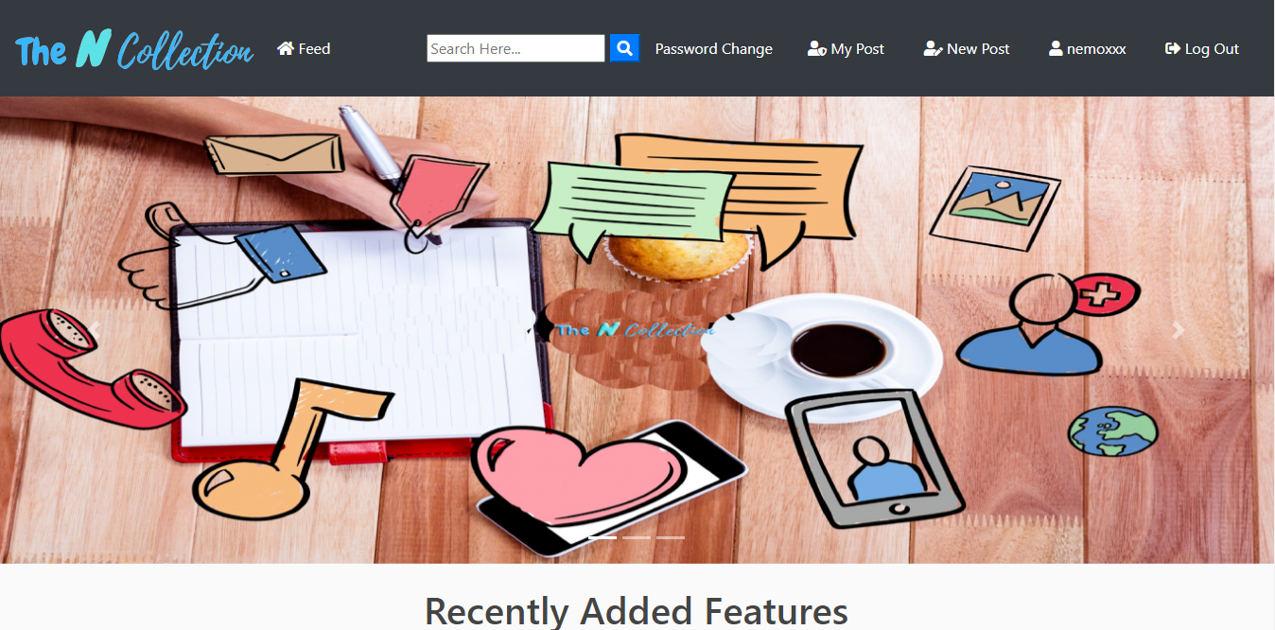

Figure 22: Homepage in Desktop view

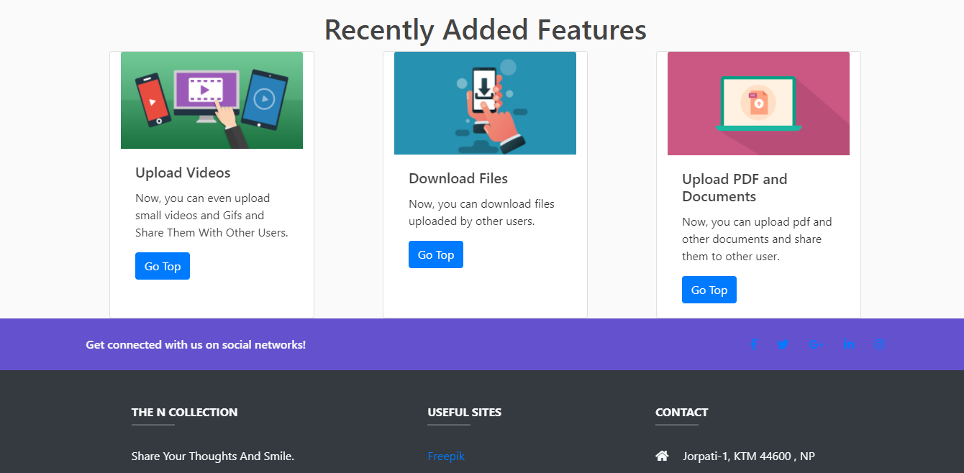

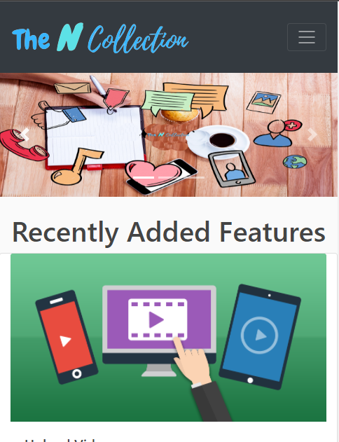 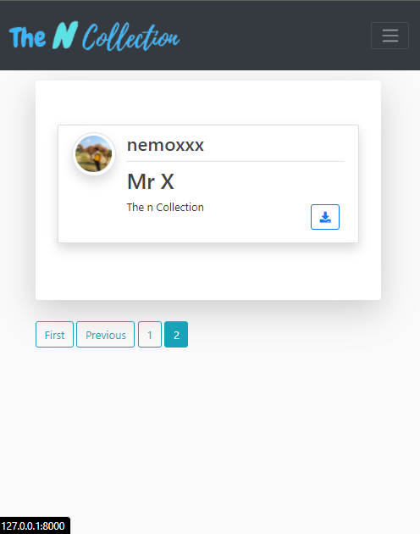

Figure 23: Homepage in mobile view

Figure 24: Feed-in mobile view

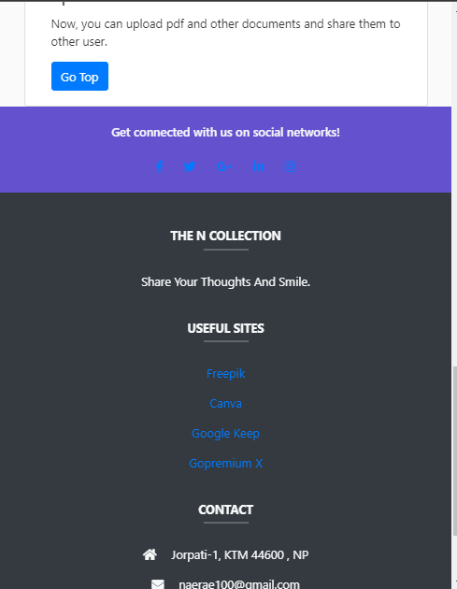 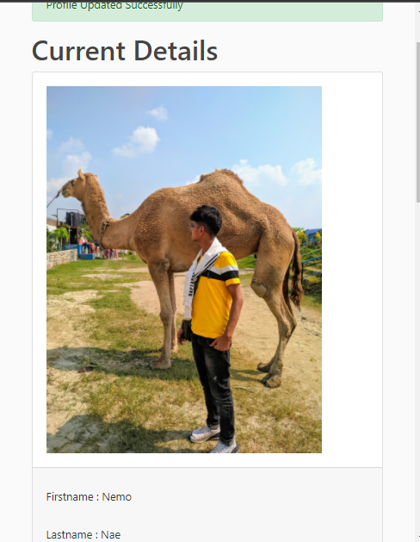

Figure 25: Footer page in mobile view Figure 26: Profile in mobile view

# Chapter 3 – Databases

The database is an organized collection of data that has been collected systematically, which allow digital data storage and management. There are different kinds of databases available for many platforms. MySQL is among the top known and highly employed SQL databases on the market. MySQL is used chiefly for Web apps, so MySQL was used for doing this project.

## Advantages of using MySQL for this project are:

* It has a comprehensive software platform that gives users more options when it comes to programming.
* It is adapted to every available platform.
* Superb performance and very fast.

## Disadvantages of using MySQL:

* It can't handle massive databases as well as others.
* It is inefficient at processing the transaction and is vulnerable to data loss.

# Chapter 4: Backend

### Python

Python is a multifunctional scripting language used almost everywhere where data, arithmetic analysis, or program code are used. This implies thus, like Java, Py isn't limited to website designing. Instead, it's frequently used for visual analytics, robotics, ai, and data management operations. However, Py does have a standard interface that appeals to both programming engineers and data professionals.



Figure 27: Python Logo

### Django

Django is a high-level Py development tool that promotes explosive growth and a simple, modern look. It's designed by software engineers to take care of a lot of the headaches of website designing so that you can concentrate on developing your applications instead of reinventing the machine. It's freely available.



Figure 28: Django Logo

## Screenshots:

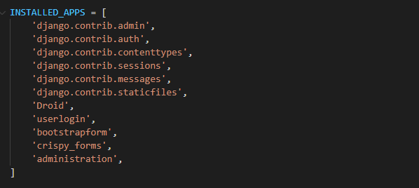

Figure 29: Installed apps

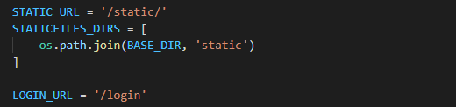

Figure 30: Static Url Configuration

### Functions figures:

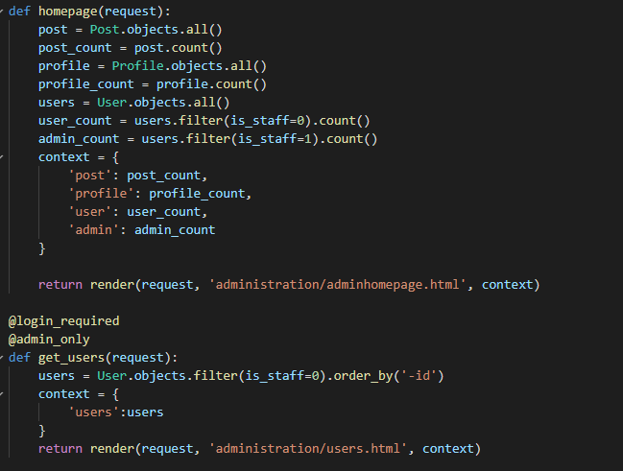

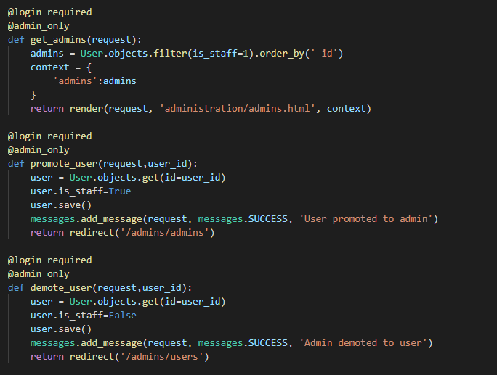

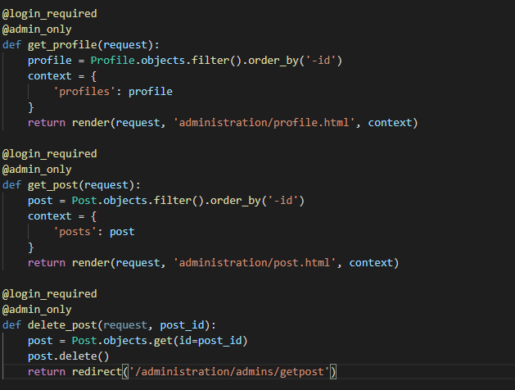

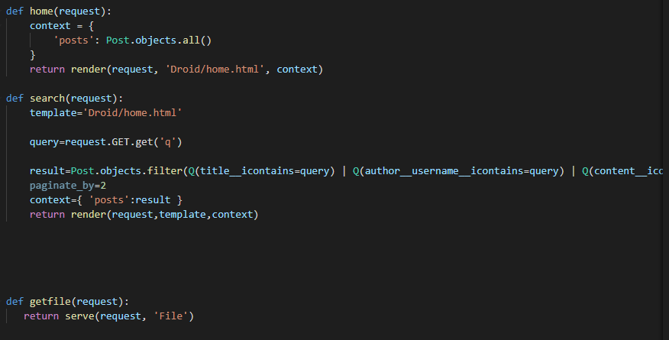

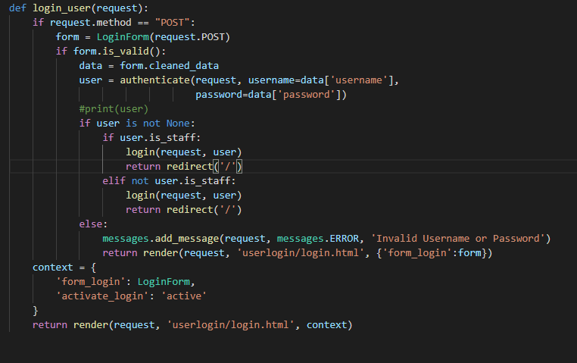

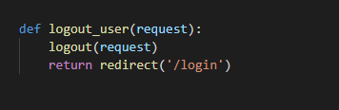

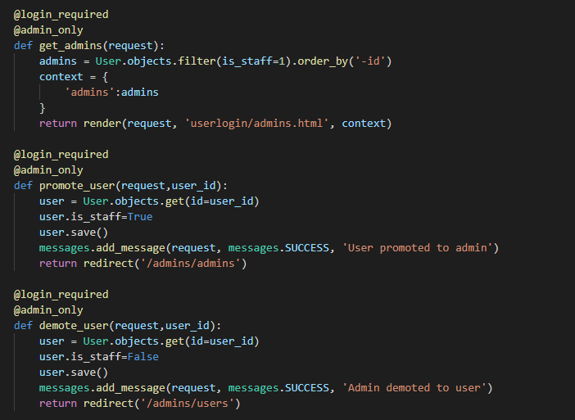

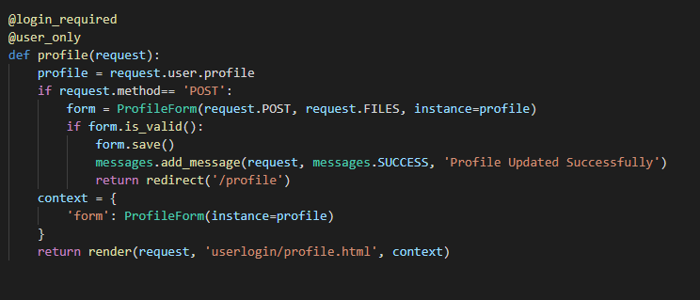

### URLs Figures:

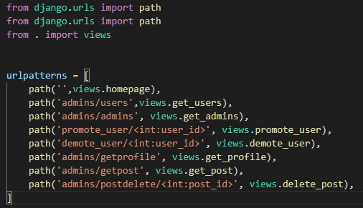

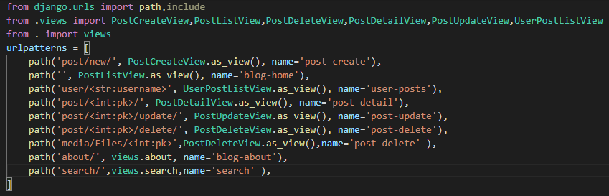

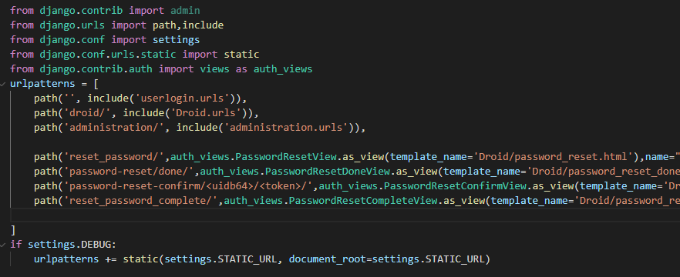

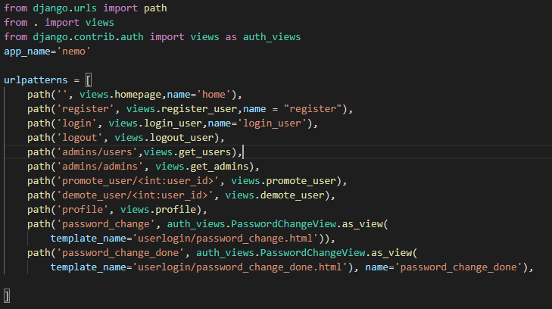

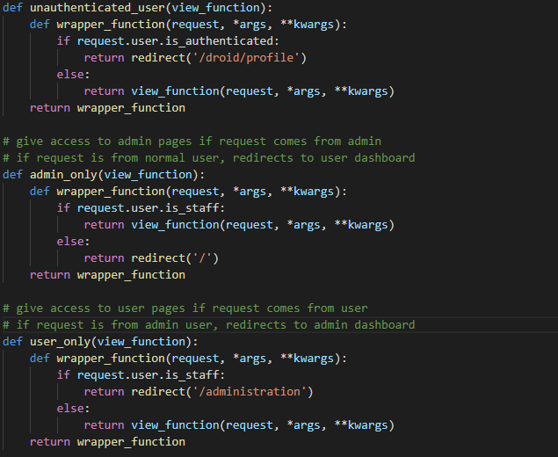

### Forms figure:

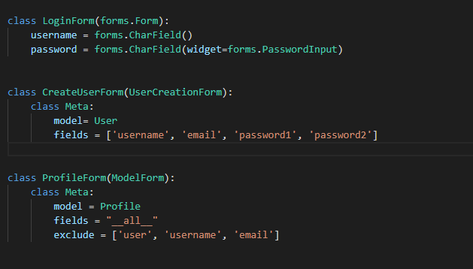

### The figure of Folder Structures:

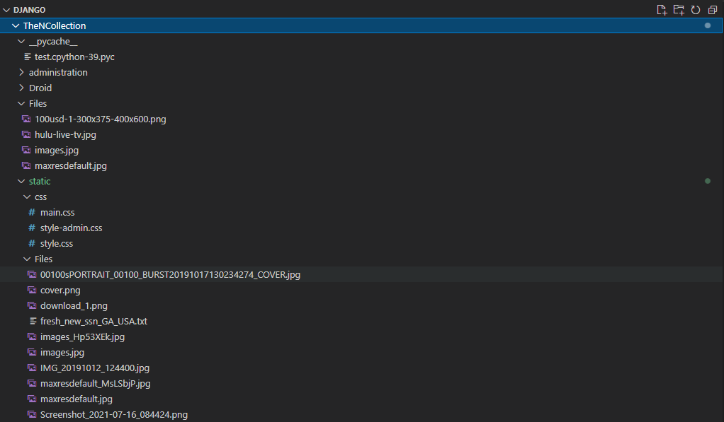

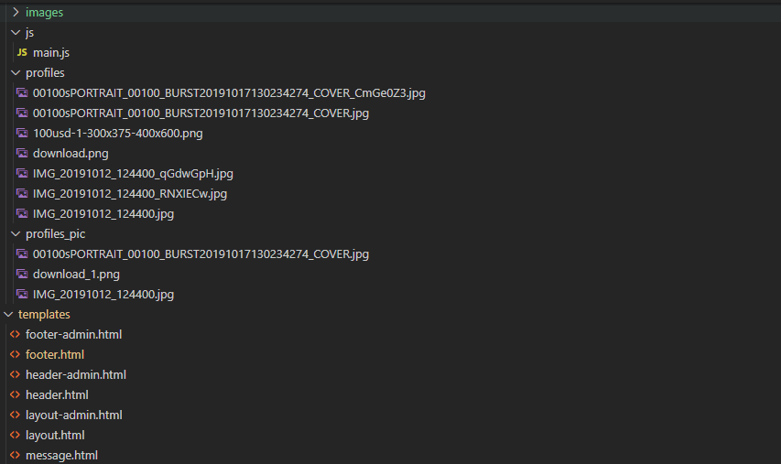

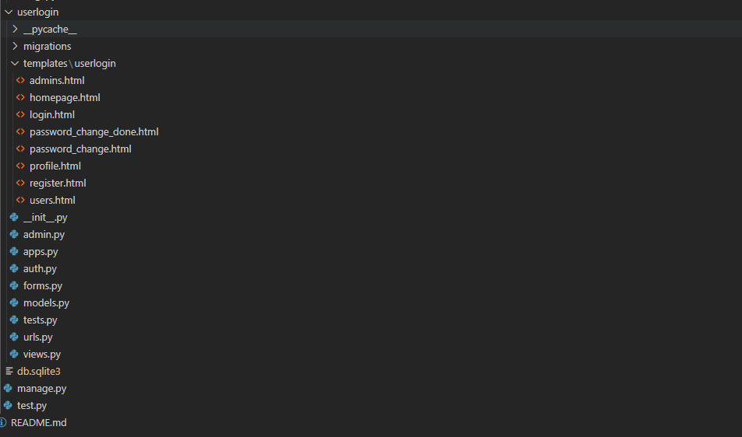

# Chapter 5: Project Issues

## Issues that occur during the project:

* Server error
* Not responsive
* CSS was not working right.

## Limitation:

* User's cant direct message other users.
* Specific files can't be searched.
* Users can't keep their files privately.

## Future work:

* Implementing comment and like in the user posts.
* Keeping files privately.
* Adding 2-step verification to keep the account secured.

## Conclusion:

To sum up, this Django-based TheNCollection comprises four key components, each with its functionality but a familiar layout. This project's major goal is to bring people and their ideas together. People may readily access their documents and files whenever they need them, from anywhere and anytime. This framework is useful for both communal and educational objectives for students. It can also be utilized as an information web in colleges and schools.

In short, I successfully met the system's criteria using the Django framework, and I have learned how to implement Django in the web app. Of course, I get few problems while accomplishing this project, but I have learned new methods and technology, and Now, I am sure I can design a better website using these frameworks.

# References:

* Cox, L., 2021. *Web Design 101: How HTML, CSS, and JavaScript Work*. [online] Blog.hubspot.com. Available at: <https://blog.hubspot.com/marketing/web-design-html-css-javascript> [Accessed 16 September 2021].
* Developer.mozilla.org. 2021. *Django Web Framework (Python) - Learn web development | MDN*. [online] Available at: <https://developer.mozilla.org/en-US/docs/Learn/Server-side/Django> [Accessed 05 September 2021].
* Kandel, P., 2021. *Campus 4.0*. [online] Campus.softwarica.edu.np. Available at: <https://campus.softwarica.edu.np/modules/developing-the-modern-web> [Accessed 8 September 2021].
* Steelkiwi.com. 2021. *Top 10 Django Website Examples*. [online] Available at: <https://steelkiwi.com/blog/top-10-django-website-examples/> [Accessed 19 September 2021].
* Smith, O., 2021. *Django Web Development in Python*. [online] Datacamp. Available at: <https://www.datacamp.com/community/tutorials/web-development-django> [Accessed 23 September 2021].